PLUVIÓMETRO
modelo: aceiro inox
Saída: RS485

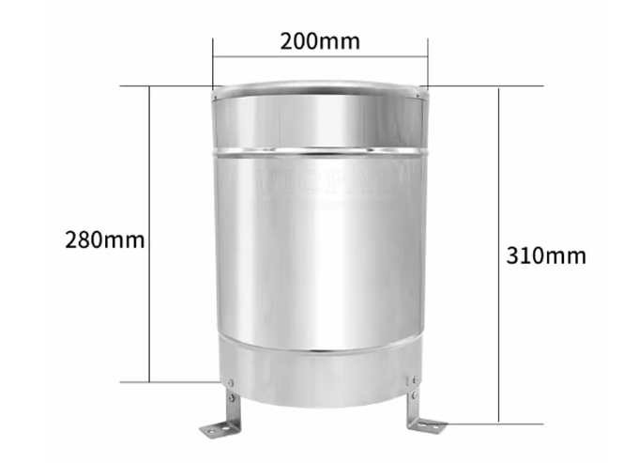

key technical indicators

Diameter of bearing rain: φ200mm; sharp edge angle: 40 ° ~ 45 °
Resolution: default 0.2 mm, optional 0.1/0.5 mm
Typical accuracy: ≤ ± 4% (indoor precipitation, based on instrument displacement)
Rainfall intensity range: 0mm ~ 4mm/min (maximum rainfall intensity allowed is 8mm/min)
Communication: 485 communication (standard ModBus-RTU protocol)
Power supply: 4.5 ~ 30V Max Power Consumption: 0.24 W working environment:
Ambient Temperature: 0-55 ° C RH: < 95% RH (40 ° C)

sensor wiring

Line color | Description | Line color | Description
Brown Line | The power supply is positive | Yellow Wire | 485A
Black line | The power supply is negative | Blue Wire | 485B

Con Modbus Poll cada pulso se ve que incrementa 2 unidades. As medidas que entrega o pluviómetro no rexistro Modbus é x10, polo que na figura aparece 12, que equivale a un acumulado de 1,2 mm (neste exemplo déronse 6 pulsos no pluviómetro).

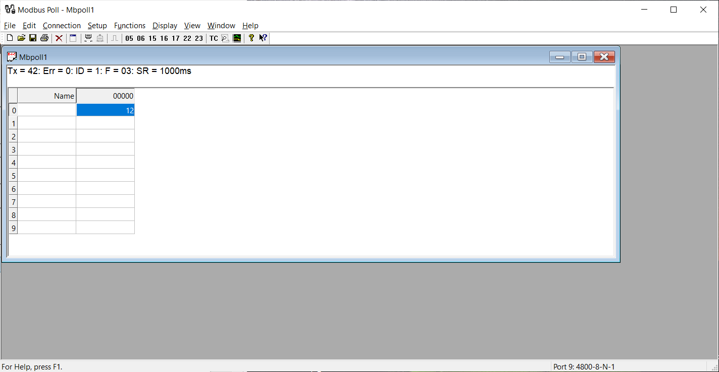

Control desde ESP32 usando conversor RS485-TTL:
